CS 3365 – Homework #3

Luis Rausseo

R11478074

**Check-out Customer Use Case (Card Payment – Successful)**

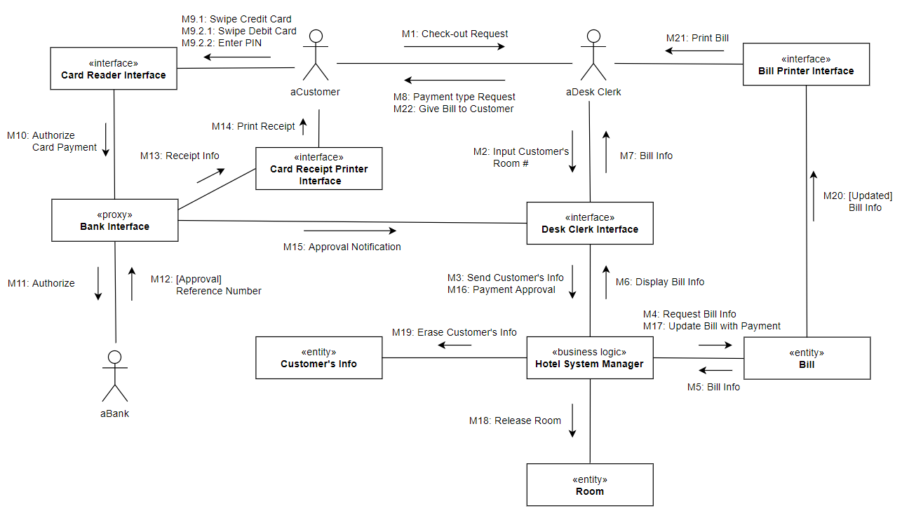

**Check-out Customer Use Case (Debit Card Payment – Wrong PIN)**

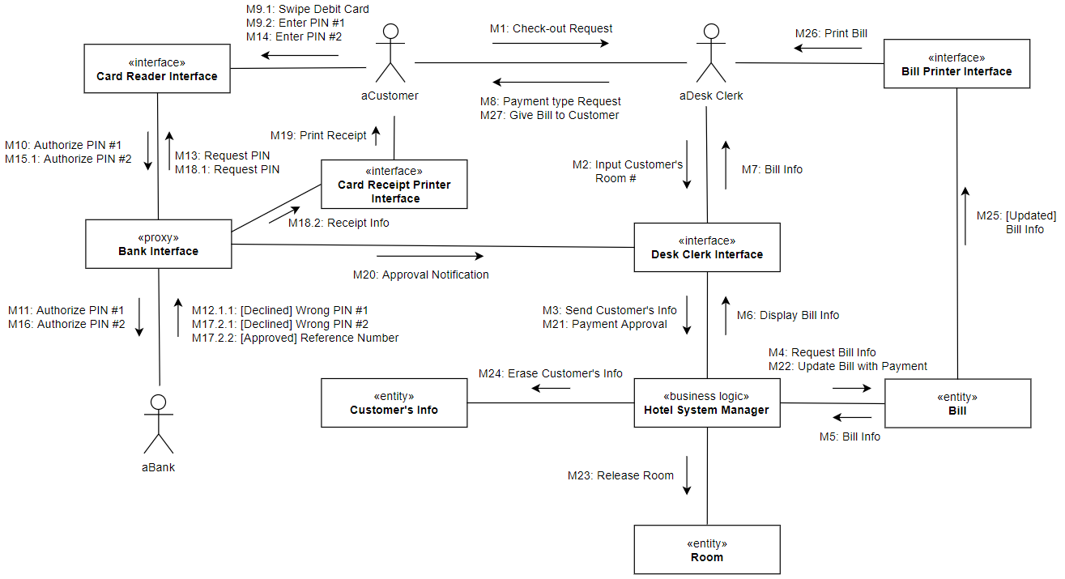

**Check-out Customer Use Case (Card Payment – Wrong PIN #3/Declined)**

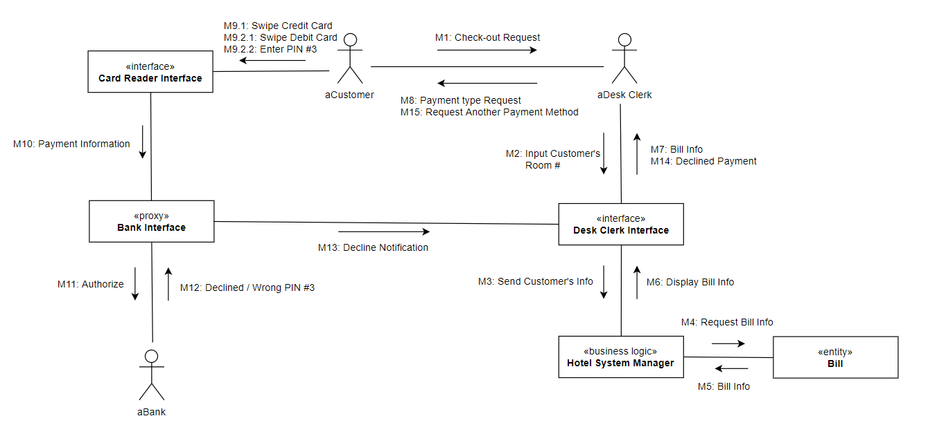

**Check-out Customer Use Case (Cash Payment)**

